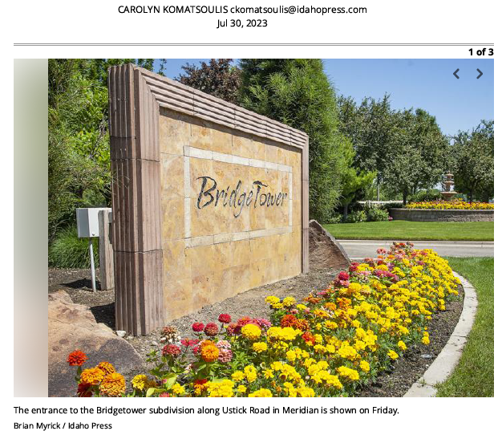**Rotten foundation': How a small group of homeowners is fighting against an atypical HOA**

* [CAROLYN KOMATSOULIS ckomatsoulis@idahopress.com](https://www.idahopress.com/users/profile/ckomatsoulis)

The brown Bridgetower sign at the entrance welcomes drivers off of Ustick Road with flowers and some small scale businesses. A kid zips through the subdivision on a scooter. Sprinkles water a green lawn. Children splash in a pool.

But inside this idyllic, tree-lined, 900-plus-home subdivision, a small group of homeowners is fighting a battle over their homeowners association. The conflict has played out in emails, social media posts, multiple legal opinions and a 150-page lawsuit from one of the members of the subdivision.

The homeowners found out in the first couple months of 2023 that their original HOA was an LLC, not a nonprofit, and was controlled by the developer instead of residents, a very atypical structure.

The neighbors consulted for this story point out the issue is bigger than one neighborhood: It highlights the lack of laws governing management, they said. It can also be a warning to would-be homebuyers to check their HOA set up.

The LLC was eventually dissolved, but technically the common areas in the subdivision are still in that dissolved LLC’s name. However, a May email from the property management company and shared with the Idaho Press said they are in the process of deeding these over to the new HOA.

The new HOA was created this year with three people on its board of directors. But it continues to draw scrutiny from the group of homeowners who say that the CC&Rs for the subdivision do not give the new HOA any legal authority to act as an HOA. CC&Rs are covenants, conditions and restrictions and are essentially the rules for the community.

“Aesthetically this place looks amazing, but it’s like you have this beautiful house with a rotten foundation,” said Ana Osborn, a homeowner in the subdivision who is part of the small group of homeowners disputing the HOA’s legal authority. “We don’t have any other purpose or desire. We just want to do things right.”

The property management company, AMI, was acquired by Keystone in 2022. In a statement, Keystone said it was a “responsive, high-quality property management firm.”

“Keystone has expended significant resources in maintaining and enhancing the Bridgetower community and looks forward to working with the Bridgetower HOA Board and all its community members to ensure a high quality of life now and into the future,” the statement said.

An attempt to reach the original developer, Frank Varriale, was not successful. An email seeking comment sent to David Fogg, an attorney working with the HOA board and AMI, was not returned. Attempts to reach the board were not successful. Steve Strickland, a member of the board, declined to comment when reached at his home.

**THE LLC APPROACH**

There is a lot of disagreement between the sides but two separate legal opinions shared with the Idaho Press agreed on one thing: Forming the original HOA as an LLC was “legally questionable,” and “problematic.” HOAs are typically nonprofits and their primary goal is to maintain property values and common areas.

“The declarant created a limited liability company (the “LLC”) with the intent that the LLC would essentially claw away, from the fee simple homeowners, certain rights related to their property and the common areas contained within the subdivision,” Fogg wrote to the property management company.

Fee simple is a term that refers to complete ownership of a property, as opposed to a lease.

The problem, according to the two legal opinions, is that the homeowners are likely liable for accidents that happen in Bridgetower’s common areas without a new HOA. For example, if someone died at the Bridgetower pool, the homeowners could be liable.

Fogg also wrote that the LLC had one sole member. Through late 2020, neither the property management company nor the homeowners were aware of the LLC or the absence of “traditional articles and bylaws,” he wrote in the legal opinion.

“Any of which alone is problematic … but together, we believe, is a significant defect and could be viewed as a purposeful attempt to misdirect and misinform homeowners,” Fogg wrote in a legal analysis.

Plus, no copies of the LLC’s operating agreement were ever included in the closing package for those who bought homes, Fogg said.

Fogg also wrote that he is unaware of any mechanism that would allow an LLC to force membership upon unknowing individuals. However, Fogg also wrote that the CC&Rs gave the LLC HOA the authority to levy assessments through an agent.

And he said the lack of transparency could open the door to litigation.

“Our analysis of the LLC is that while we understand what was attempted, the execution of mashing together an LLC operating agreement and traditional HOA bylaws created a confusing, extremely ambiguous, and largely unenforceable document,” Fogg said.

**AN ATTEMPT AT A SOLUTION**

In December, Osborn — one of the homeowners — and her neighbor Trinity Burak, noticed that their HOA assessment increased by $200 a year. They started looking into the structure of the subdivision and found out about the LLC situation.

The management company said in a letter to homeowners that the assessment was last set before 2009. Expenses had increased over 13 years and the community had aged, the letter said.

“We did not realize what we were up against at that point,” Burak said. “Everyone just assumed we were told when we bought our houses that we were part of an HOA.”

Burak and Osborn, along with a third neighbor, met with the management’s attorney in mid-February, they said. A week later, they went to the annual meeting and found out that the old LLC HOA had been dissolved the day before, on Feb. 22.

Plus, on the 22nd, the new HOA had been incorporated, by Jeffrey Wolff, Joe Gruber and Steve Strickland, the board of directors.

Fogg wrote in his opinion that paragraph 4.7 of the CC&Rs said that the LLC’s assets can be dedicated or transferred to a public body or another nonprofit with similar purposes.

But a legal opinion provided by attorney Brindee Collins to the group including Osborn and Burak disputes that the incorporation was handled correctly. In Collins’ mind, a new nonprofit HOA is the right way to go, but that the execution was wrong.

For example, Collins wrote that the original CC&Rs that govern the subdivision don’t compel membership in the new HOA. Essentially, Collins said they created a new HOA that doesn’t have the authority to assess fees or perform other HOA actions.

Collins asserted that 70% of the homeowners would have to vote to approve the changes and new entity.

“It has not been created pursuant to any authority in the CC&Rs,” Collins wrote. “The terms of the CC&Rs, as they are presently written, directly conflict with its existence and operation.”

In the meantime, Burak said they are in a “holding pattern.”

“Some of us have not paid our assessments. We’re in the process of putting that money in an escrow account,” Burak said. “We paid, because there is not a legal entity to pay to.”

The Friends of Bridgetower are also unhappy that the homeowners did not get to vote on the three people chosen for the board of directors, who were previously involved on the advisory and architectural control committee.

In an update from the management company in March, AMI said that the developer chose the three people selected. The developer required those specific people, AMI said.

“He felt they would provide continuity and be the best selection at this time for Bridgetower to lead through this transition,” the update said. “The change in management style could not have taken place without the concurrence of the developer.”

**FIGHTING BACK**

The group’s efforts to fight back against the new HOA have drawn criticism from neighbors, a cease and desist letter and a slew of legal back-and-forth, Osborn and Burak said.

“As this small group, when we started talking, we seriously thought, this is messed up,” Burak said. “We’re the ones who should have some say in what goes on.”

Burak said they have been referred to as a “just a small disgruntled group of homeowners.”

Their group, the Friends of Bridgetower, also set up a website: [bridgetowerhoa.com](http://bridgetowerhoa.com/). The website drew a cease and desist letter from Fogg’s company, ELC Legal Services, LLC, which said that the website contained “false, misleading, and potentially defamatory statements.”

The letter also said the website confuses the homeowners in the area about how to contact the property management company.

“For example, we recently learned of an issue related to gophers that was directed not to the property management company, but to Your website,” the letter wrote.

A homeowner, Adam Simonds ended up filing a 240-page lawsuit that he hopes to turn into a class action lawsuit. He is aligned with the group that includes Osborn and Burak but his actions are independent, Burak said. Ultimately, the judge decided he had to rewrite the complaint more clearly.

It’s now a 150-page lawsuit that alleges breach of contract, three counts of negligence, tortious interference, unjust enrichment and collusion to defraud.

At one point, the Friends of Bridgetower tried to broker an agreement to get the new HOA dropped out of the lawsuit if certain members of the board resigned and new ones were appointed. The Friends of Bridgetower said those who should resign had already expressed interest in doing so. Emails shared with the Idaho Press appear to show that the board did not consider this an actual proposal from Simonds himself and were concerned it was “Quid pro Quo.”

Ultimately, Osborn and Burak also said they reached out to different officials. They said something ought to change in state law to ensure transparency, that all the paperwork is in place and the organization is properly set up. The two want to ensure that homeowners can access financial documents and contracts related to HOAs and management companies.

“Nobody wants to touch the hot potato of HOAs, it’s a four-letter word,” Burak said.

“Why do we have to go through this nightmare?” Osborn added. “One-thousand households, right now, we’re in limbo.”